Lake County:
Offender Reentry Housing Collaborative Report

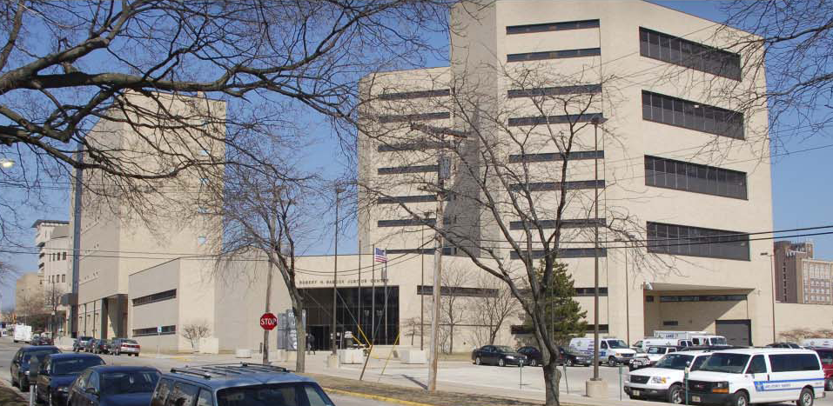

(Lake County Jail)
(Credit Lake County Sheriff’s Annual Report)

June 15th, 2009

Submitted To:
The Corporation for Supportive Housing

Submitted By:

Cathy Tasner Curran
Executive Director - Cathy Tasner Curran
Pads Crisis Services
North Chicago, IL 60064

Core Principles for Reentry Collaborative

In May of 2008, the governor’s office released a report entitled “Inside Out: A Plan to Reduce Recidivism and Improve Public Safety.” To support the housing recommendations in the Governor’s Reentry Report the Corporation for Supportive Housing (CSH) partnered with the Illinois Department of Corrections (IDOC) and the Illinois Division of Mental Health in releasing fourteen (14) planning grants within ten (10) target areas to assist communities in assessing the need for reentry housing and supportive services in their area.

      - Planning for services prior to release from an institution is essential for communities and that building capacity of the community is necessary to plan for the safe return of our former community members.
- Multiple strategies and partnerships need to be deployed as no one strategy can help all individuals and families who are homeless.
- As a result of this planning process, all area agencies from multiple systems will work together as partners to ensure successful, long-term outcomes for individuals returning from correctional facilities. This working together includes planning, identification of current services and housing, strengths and weakness, and the development of future goals for growth and development of housing, services, and integration. Some of the systems included and reviewed in our partnership will need to include: mental health, substance abuse, county corrections, state corrections, housing, homeless emergency systems, and health care.
- Services need to be designed and delivered in a manner that is accessible to people who are disadvantaged or marginalized.
- We believe that all individuals and families should have permanent, safe, affordable housing with necessary supportive service.

Lake County

Offender Reentry Housing Collaborative Report

The purpose of this report is to advocate for housing opportunities among ex-offenders in Lake County.

Introduction: Although Lake County did not get a planning grant; they came together to submit a report on reentry housing following the basic principles of funded reentry grant groups. There was a strong feeling that Lake County can get overlooked in the state. It is far north and near Chicago. Lake County has some extremely wealthy communities but has pockets of poverty in communities that have few resources to break a cycle of repeated incarceration. There is a need for housing and services for this population in the communities that are receiving large numbers of persons returning to their home communities. There are great pockets of need amongst wealth. Lake County is a place to build wealth and opportunity in areas of need.
There is much to recommend in Lake County for expansion and investment in reentry:

- The Coalition to Reduce Recidivism is a group of individuals and organizations dedicated to eliminating unnecessary use of correctional facilities through creative programming. Patricia Jones and the Township have been leaders in developing resources and building community resources for this group. This group includes representation from the State’s Attorney’s office, the Jail, public defender’s office, judges, social service, and housing organizations. They meet monthly to develop resources for impacted families and individual offenders.
- Waukegan has a long history of success with the Oxford House Model with the statewide organizer located in Waukegan.
- PADS Crisis Services has a long history of serving the homeless, many having criminal history and denied housing opportunities. Research shows developing housing with sufficient services can save money for the county, cut crime, and better meet the needs of this group. PADS hopes to develop permanent housing and access federal dollars for safe and accessible housing
- The County currently spends 109.3 million dollars annually on law and judicial services, which includes the Jail, Courts, and county law enforcement according to Lake County Budget documents. The jail currently houses an average of 634.6 detainees per day in a jail built for 720 people. There are opportunities to invest criminal justice dollars elsewhere.
- State Rep Eddie Washington has been a state leader in reentry issues. Senator Terry Link is amongst the Democratic Senate Leadership and has been an advocate for vocational programming for ex-offenders.

Lake County Background Information

Lake County with a population of 712,453 is a study of contrasts; affluence and extreme poverty, urban and rural communities. An increasing number of low-to-moderate-income residents in Lake County need assistance meeting basic needs. The growing need for basic housing, transportation and healthcare is simply outpacing the county’s ability and inclination to provide adequate service.

Although Lake County is one of the most affluent counties in Illinois as measured by per capita income, aggregate statistics mask the tremendous disparity in indicators of prosperity that exists within the county. The average household income in Lake County’s most affluent community is 5 times higher than in its poorest community, and its highest average per capita income is 8 times higher than its lowest. The U.S. Department of Health and Human Services has designated North Chicago, Round Lake Beach and the low-income populations of Waukegan and Zion as “target area communities.”

Statement of Needs for Ex-Offenders in Lake County

According to the Lake County Coalition to Reduce Recidivism, over 225 ex-offenders return to Lake County each month. Approximately 100 ex-offenders return to Waukegan, 75 return to North Chicago, and 50 return to Zion each month. Round Lake, Fox Lake, and Gurnee are three communities that also receive a smaller but significant number of parolees and probationers. (See the chart on the next page for a list of the releases from IDOC for Lake County. This does not include County Jail statistics).).

In the Lake County 10-Year Plan to End Homelessness, re-entry of ex-offenders was one of the issues cited as contributing to the number of homeless people in the county. Lake County’s ex-offender reentry programming is integral to its homeless population’s reduction efforts.

Offenders with past problems of homelessness or who are presently concerned about the prospect of having no place to stay upon their release into the Lake County community expressed concerns about the development of release plans several months prior to their parole, and several months after being paroled into the community. This time period is crucial to their success on supervision. Some individuals have ‘sat’ in the Illinois Department of Corrections (IDOC) facilities until their entire sentence was completed due to ineligibility for parole because of lack of acceptable housing.

Lake County Juvenile and Adult Population by Zip Code - 3/08
ZIP Code | City | State | Direct Discharge | Supervised Discharge | Parole Population | Juvenile Parole | Total All
60085 | WAUKEGAN | IL | 41 | 207 | 292 | 33
60099 | ZION | IL | 14 | 99 | 133 | 11
60064 | NORTH CHICAGO | IL | 5 | 84 | 87 | 8
60073 | ROUND LAKE | IL | 6 | 54 | 60 | 4
60087 | WAUKEGAN | IL | 8 | 56 | 52 | 5
60031 | GURNEE | IL | 1 | 18 | 26 | 1
60060 | MUNDELEIN | IL | 3 | 15 | 18 | 10
60002 | ANTIOCH | IL | 4 | 17 | 23 | 1
60030 | GRAYSLAKE - THIRD LAKE | IL | 1 | 14 | 25 | 0
60046 | LAKE VILLA | IL | 2 | 12 | 21 | 3
60020 | FOX LAKE | IL | 1 | 17 | 19 | 0
60041 | INGLESIDE | IL | 0 | 14 | 13 | 1
60047 | LAKE ZURICH | IL | 1 | 13 | 9 | 0
60089 | BUFFALO GROVE | IL | 0 | 12 | 10 | 0
60084 | WAUCONDA | IL | 3 | 6 | 12 | 1
60096 | WINTHROP HARBOR | IL | 1 | 7 | 8 | 1
60079 | WAUKEGAN | IL | 2 | 5 | 6 | 0
60048 | LIBERTYVILLE | IL | 0 | 7 | 5 | 0
60010 | BARRINGTON | IL | 0 | 4 | 7 | 1
60042 | ISLAND LAKE | IL | 0 | 3 | 7 | 0
60044 | LAKE BLUFF | IL | 1 | 2 | 7 | 0
60083 | WADSWORTH | IL | 1 | 3 | 5 | 0
60011 | BARRINGTON | IL | 0 | 6 | 0 | 2
60015 | DEERFIELD | IL | 1 | 3 | 4 | 0
60061 | VERNON HILLS | IL | 1 | 3 | 2 | 1
60040 | HIGHWOOD | IL | 0 | 3 | 3 | 0
60035 | HIGHLAND PARK | IL | 1 | 2 | 3 | 0
60045 | LAKE FOREST | IL | 0 | 2 | 0 | 0
60086 | NORTH CHICAGO | IL | 1 | 0 | 1 | 0
60037 | FORT SHERIDAN | IL | 0 | 0 | 1 | 0
60049 | LONG GROVE | IL | 0 | 0 | 1 | 0
60069 | LINCOLNSHIRE | IL | 0 | 0 | 1 | 0
60088 | GREAT LAKES | IL | 0 | 0 | 1 | 0
60075 | RUSSELL | IL | 0 | 0 | 0 | 0
60092 | LIBERTYVILLE | IL | 0 | 0 | 0 | 0

Barriers to Housing:

- Many private landlords do not rent to ex-offenders.
- The nature of the offense can be a barrier.
- Substance abuse issues can limit ability to sustain housing. Relapses can trigger loss of housing.
- Mental health issues can impair housing retention. Local providers have limited funds to deal with outpatient care. It can take a great deal of time to obtain assessments and prescriptions. Many clients need help getting these assessments and prescriptions.
- Documentation of mental illness can be a problem. The major issues are how to identify mental illness while persons are incarcerated, and how to acquire the documentation needed to obtain SSI and SSDI benefits upon release.
- Transportation is not available in many parts of the county.
- The stigma of being an ex-offender keeps many from housing. There is a need to educate and inform the public in order to reduce NIMBYism.

Strengths, Weaknesses, Opportunities and Threats

This analysis compares the strengths, weaknesses, opportunities, and threats (SWOT Analysis) facing the Lake County community and ex-offender homelessness and reentry housing.

STRENGTHS:
- Broad-based Continuum of Services
- Educated Population
- Illinois Department of Human Services provides some funding
for security deposits and rent assistance
      - Prairie State Legal Services provides legal counseling and
representation to prevent eviction and loss of housing assistance
        - Lake County Jail employs a part-time reintegration specialist to
provide discharge-planning services to help incarcerated persons
locate housing and supportive services upon their release.
- Large number of Oxford Homes embedded in the community with strong chapter support.
- Broad governmental/faith-based/social service support and advocacy through the Coalition to Reduce Recidivism
        - 140-bed unrestricted seasonal emergency shelter
        - 42-bed emergency shelter for families

WEAKNESSES:
- Limited permanent housing for ex-offenders
- Limited availability of transitional housing
- Continuum of Care funding is already maximized
- Lake County Transit System covers limited geography; service from 8 pm to 6 am not available.
OPPORTUNITIES:
- Possible transitional housing for female offenders
- Increase beds from 8 to 12 at male transitional housing already in
existence
      - Continuum of Care as possible funding source in the future
        - Transitional Housing as part of the American Recovery and Reinvestment Act (ACCRA) and the U.S. Department of Housing and Urban Development – Homelessness Prevention and Rapid Re-Housing Program (HPRP).

THREATS:
- Neighborhood resistance
- Unstable funding
- Housing that prohibits those with sex offender backgrounds
- Funding reductions for supportive services

Successful re-entry into the community is a collaborative effort between many parties, including but not limited to: regional and local government systems, local law enforcement, the court system, support services, treatment providers and the offenders themselves. Housing is of key importance to safe re-entry and is a practical hub around which necessary protections and supports can be structured such as effective monitoring, compliance with treatment and supervision requirements.

Conclusion

At this time, we recommend the traditional housing program approach along with a model drawn from Opportunity Reconnect, a program used in Essex County, New Jersey. The traditional housing approach is where persons move from homelessness to emergency shelter to transitional housing and then to permanent housing allowing each person to progress through the system. Through the Opportunity Reconnect model, working in a single location at Essex County College, returnees are able to access all the programs and services available in the county to help them become productive, law-abiding citizens. Case managers assist participants in navigating and successfully connecting to complex service delivery systems.

This model could be overseen by a steering committee of its partners –the City of Waukegan, College of Lake County, Lake County Probation, the Illinois Department of Corrections, the Illinois Prison Review Board, the Lake County Coalition to End Recidivism and the Lake County Continuum of Care. The model could serve as a one-stop shop reentry center for returning Lake County offenders. Multiple government agencies and community-based organizations could collaborate across delivery systems to provide critical services that include employment services; case management, substance abuse treatment, education, mental health treatment and family strengthening. Because it takes advantage of existing funding and staffing resources, the Opportunity Reconnect model would not require large additional financial or resource investment by government or community-based organizations.

Our long-term goal is to provide a program similar to St. Leonard’s Ministries located in Chicago. St. Leonard’s Ministries provides comprehensive permanent supportive housing and employment services for those released from prison without resources. St. Leonard’s Ministries recidivism rate for residents is 20% compared with the state average exceeding 50%.

Prisoner re-entry is not a criminal issue, nor is it simply a race or poverty issue – it is a human rights issue, one that impacts millions of individuals nationally, families and communities across Illinois and the country. Formerly incarcerated individuals with few supports and services are more likely to continue to rely on public assistance, commit crimes, re-incarcerate and further drain government and community resources, rather than add to the productivity of our “human capital.” We simply cannot afford to continue the cycle of incarceration and recidivism. Lake County should be encouraged through greater state support, and its efforts should be broadened in both scope and scale.

